You have a keypad with 9 buttons, numbered from 1 to 9, each mapped to lowercase English letters. You can choose which characters each button is matched to as long as:

* All 26 lowercase English letters are mapped to.
* Each character is mapped to by **exactly** 1 button.
* Each button maps to **at most** 3 characters.

To type the first character matched to a button, you press the button once. To type the second character, you press the button twice, and so on.

Given a string s, return *the* ***minimum*** *number of keypresses needed to type* s *using your keypad.*

**Note** that the characters mapped to by each button, and the order they are mapped in cannot be changed.

**Example 1:**

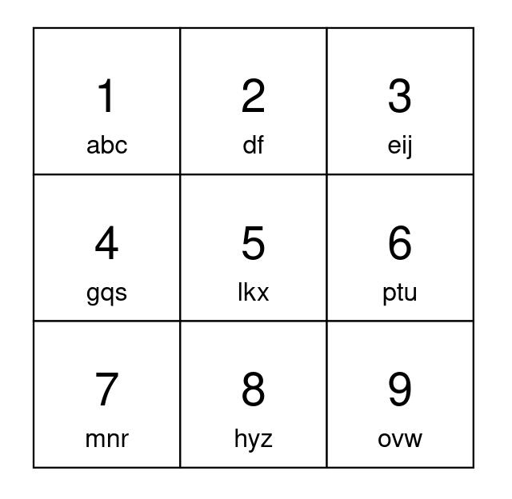

Input: s = "apple"  
Output: 5  
Explanation: One optimal way to setup your keypad is shown above.  
Type 'a' by pressing button 1 once.  
Type 'p' by pressing button 6 once.  
Type 'p' by pressing button 6 once.  
Type 'l' by pressing button 5 once.  
Type 'e' by pressing button 3 once.  
A total of 5 button presses are needed, so return 5.

**Example 2:**

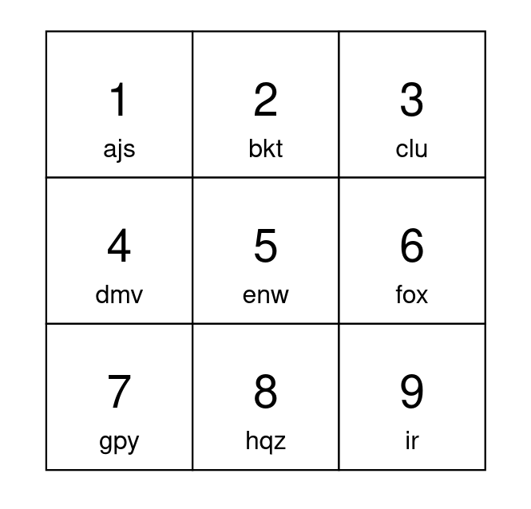

Input: s = "abcdefghijkl"  
Output: 15  
Explanation: One optimal way to setup your keypad is shown above.  
The letters 'a' to 'i' can each be typed by pressing a button once.  
Type 'j' by pressing button 1 twice.  
Type 'k' by pressing button 2 twice.  
Type 'l' by pressing button 3 twice.  
A total of 15 button presses are needed, so return 15.

**Constraints:**

* 1 <= s.length <= 105
* s consists of lowercase English letters.